Module 2.1: Building a Model
SageModeler Instruction

Follow these steps with your team to create your model on how climate change impacts your chosen value.

- Choose one member of your team to create a copy of the SageModeler Template or visit https://tinyurl.com/AISciModel.

The whole team will work on one model together.

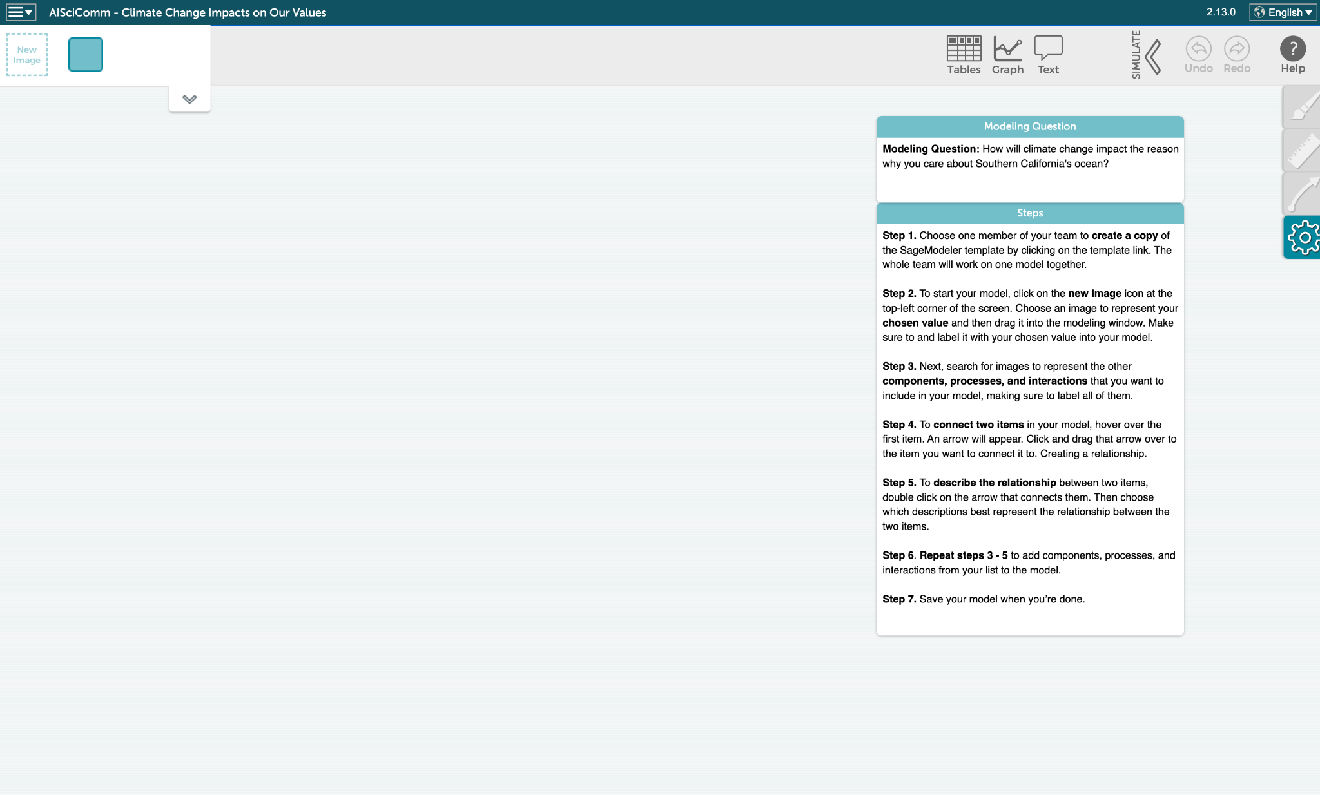

- To start your model, click on the new image icon at the top-left corner of the screen.

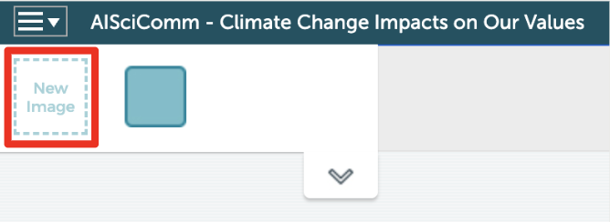

Choose an image to represent your chosen value. Press “Add Image.”
Example: Search “fish” for the value seafood.
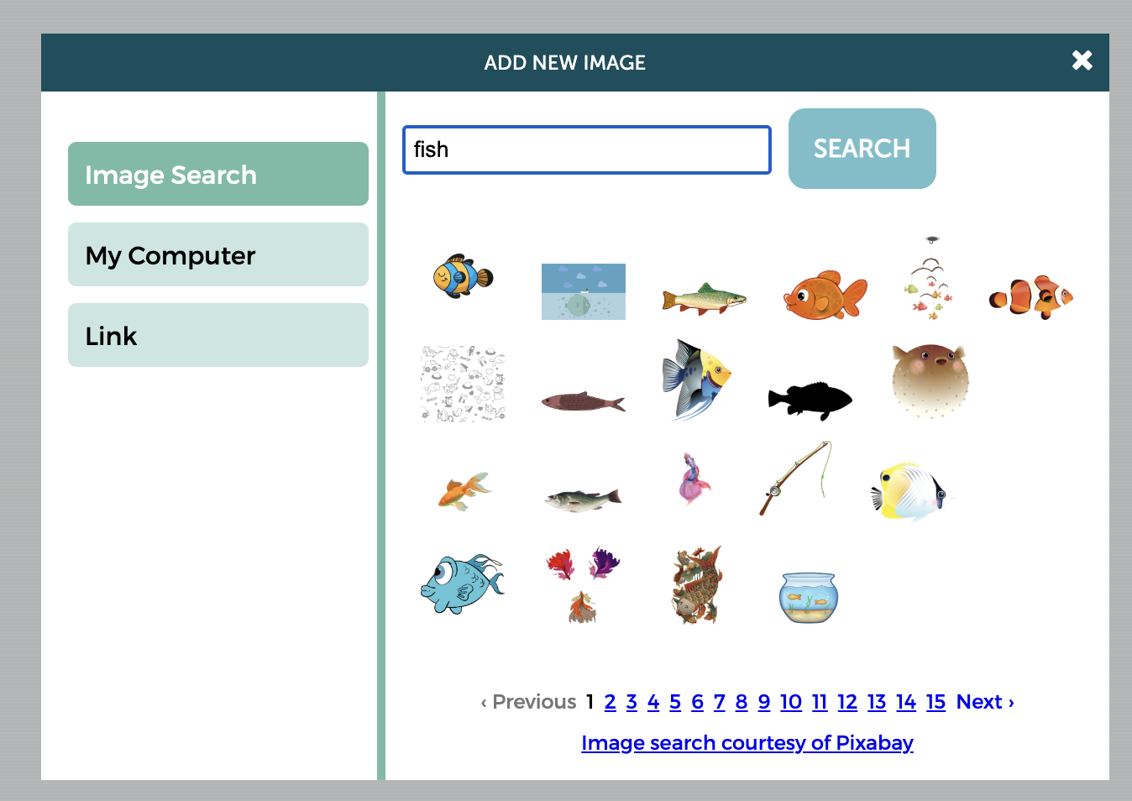

Drag the image in the modeling window. Make sure to label it with your chosen value in your model.
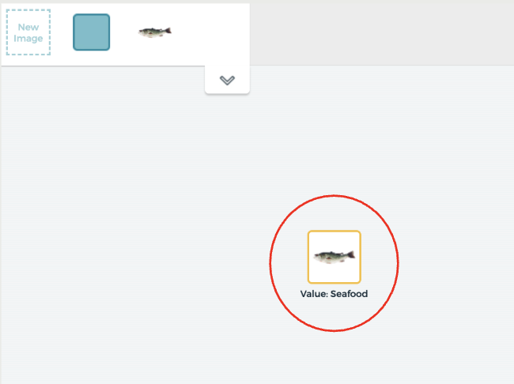

- Search for images to represent the other components, processes, and interactions that you want to include in your model. Label all of them.

Example:
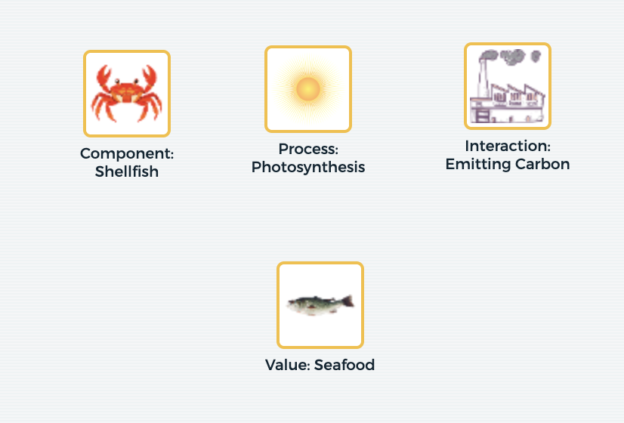

- To connect two items in your model, hover over the first item. An arrow will appear.
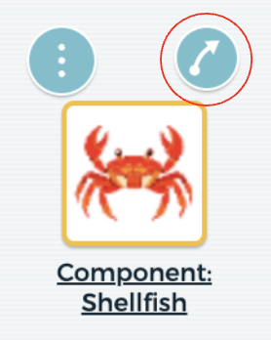

Click and drag that arrow over the item you want to connect it to. Creating a causal relationship.



- To describe the relationship between two items, double-click on the arrow that connects them.
  - Positive relationship: As one factor increases, the second factor also increases.
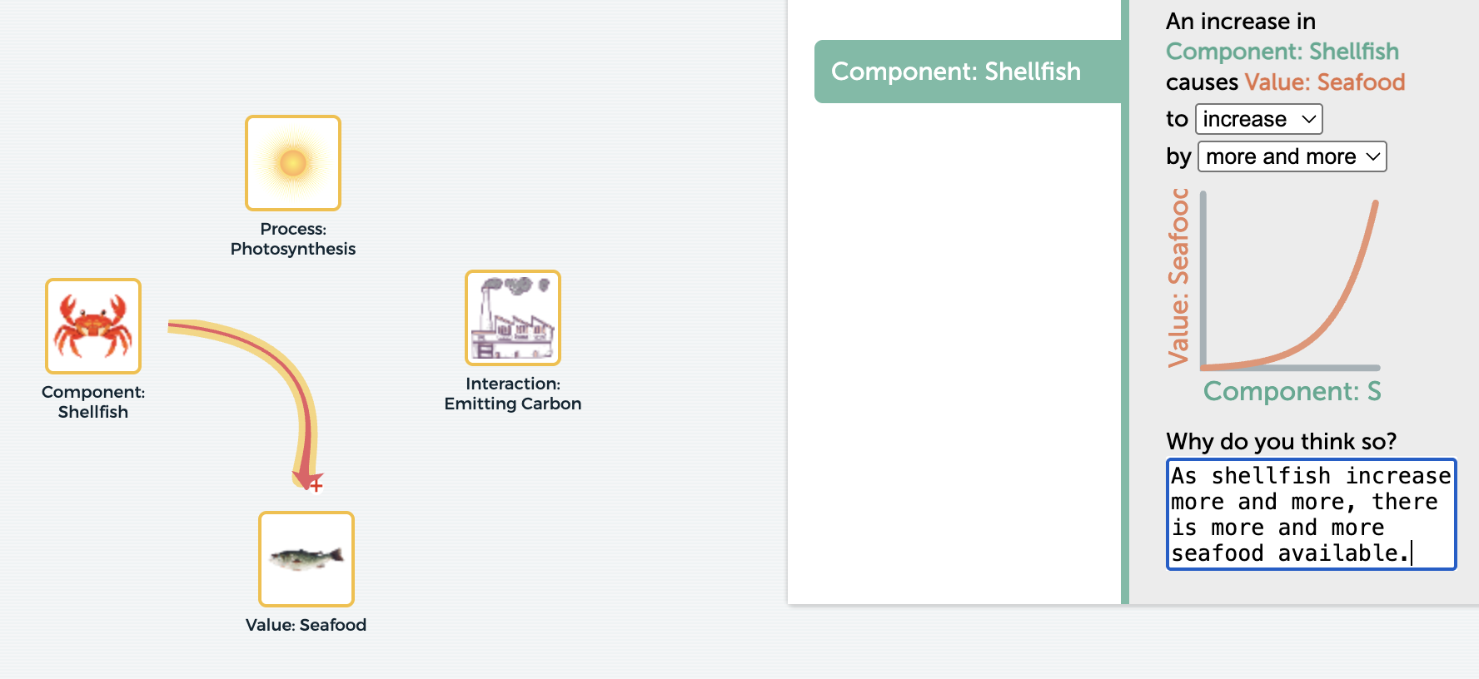

  - Negative relationship: As one factor increases, the second factor decreases.
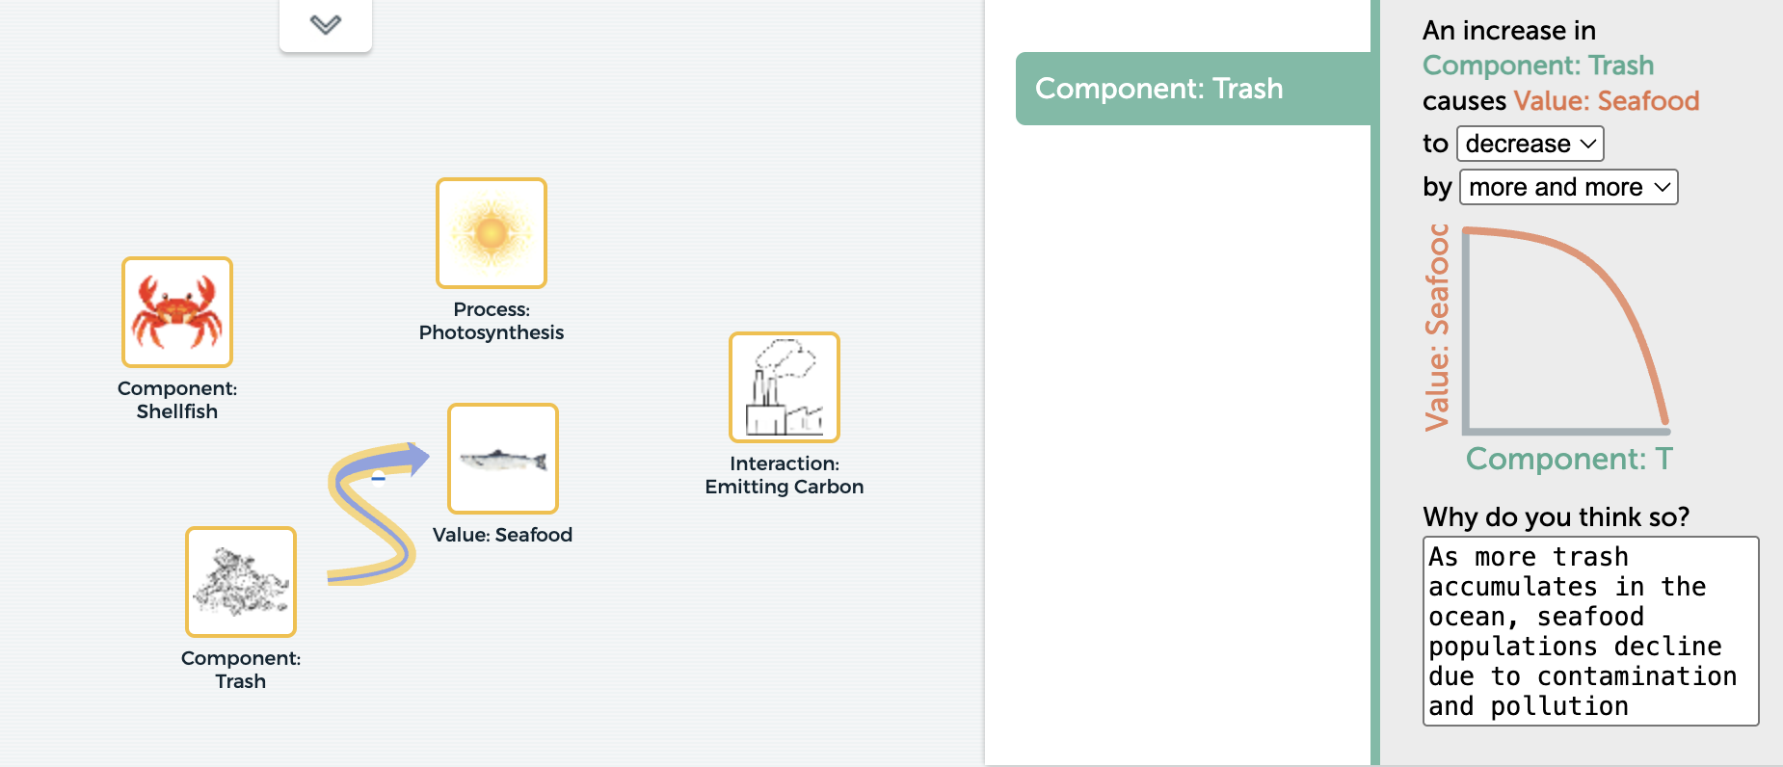

  - Varied relationship: As one factor increases, the second factor can increase or decrease depending on different conditions.

  - OPTIONAL: To make sense of the various interactions, you may add a brief explanation for the relationships (positive, negative, varied).
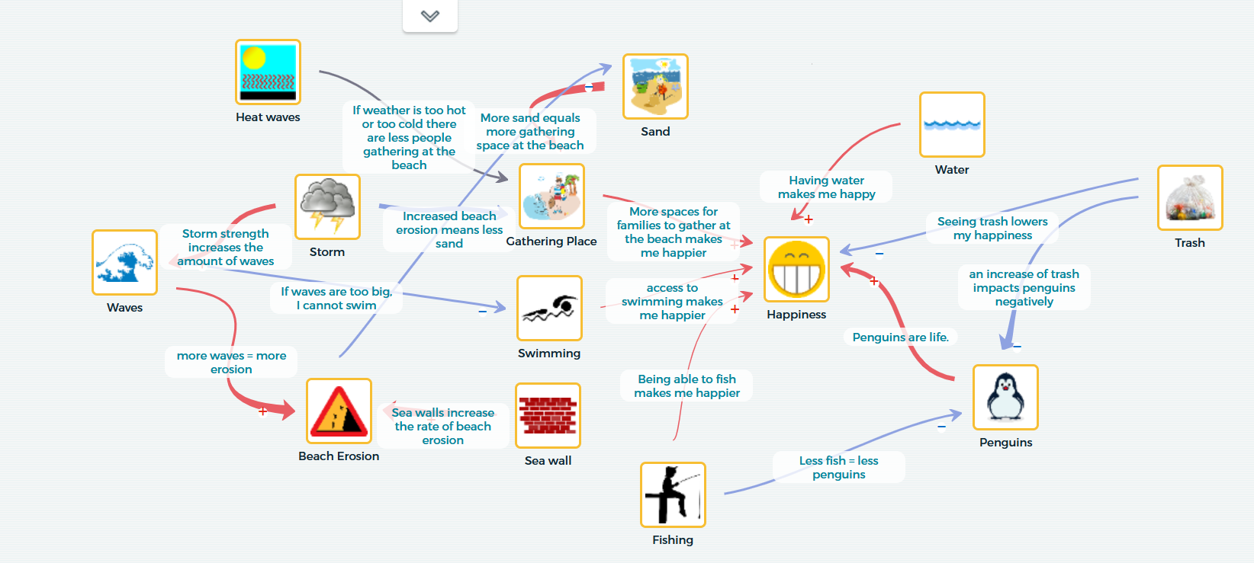

- There are different types of causal relationships that you can model. Try to model different types of causal relationships.
  - Linear Chain (A → B)
Concept: A direct cause-and-effect relationship where one element or process directly impacts another.

Example:
A heavy storm (A) physically prevents fishing vessels from leaving port, directly reducing the immediate supply of fresh seafood (B).
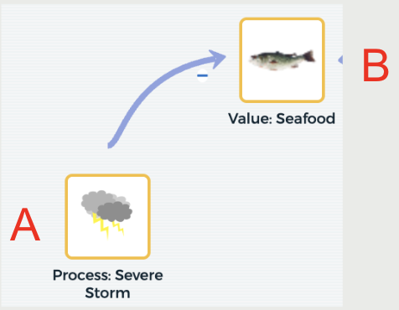

  - Causal Chain (A → B → C)
Concept: A multi-step sequence where an initial event triggers an intermediate change, which then leads to a final outcome.

Example:
When factories release carbon dioxide into the air (A), the ocean absorbs it and becomes acidic (B), dissolving oyster shells and reducing seafood yields for farmers (C).
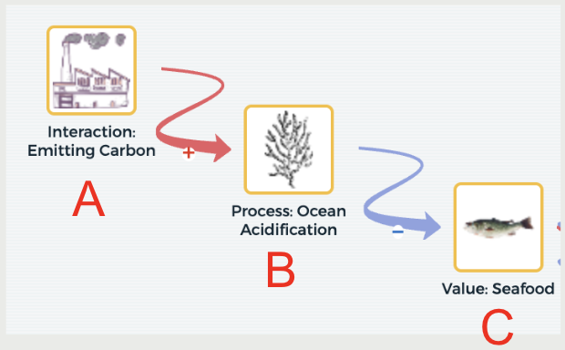

  - Feedback Loop (A → B; B → A)
Concept: A circular relationship where the outcome of a process feeds back into the original cause, amplifying (positive feedback) or reducing (negative feedback) the effect over time.

Example:
Intense fishing (A) drives down wild fish populations (B), creating market scarcity that raises prices and incentivizes companies to fish even harder (A), driving stocks into a deeper decline.
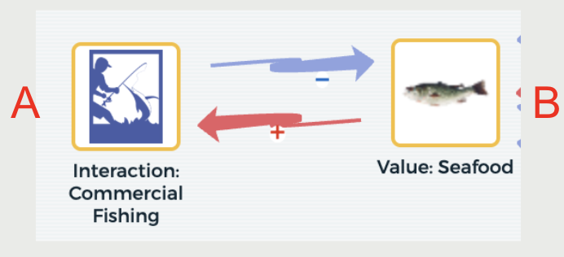

  - Indirect Link (A → B; B → C; A → C)
Concept: A variable (A) influences an outcome (C) both indirectly through an intermediate variable (B) and through a separate direct pathway.

Example:
Indirect Pathway (A → B; B → C): : Increased sunlight boosts phytoplankton growth
(A → B), which feeds small marine life and ultimately builds up commercial fish populations (B → C).
Direct Pathway (A → C): Sunlight directly warms surface waters and alters fish migration routes (A → C), changing where fish gather and affecting local seafood availability and prices.
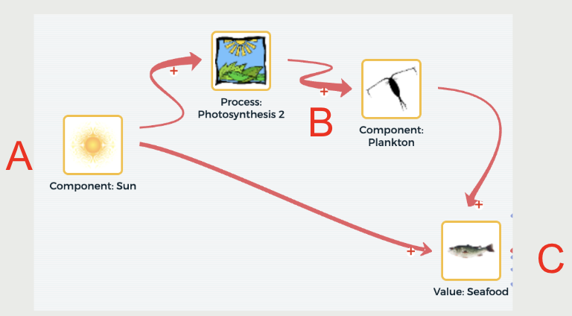

- Continue to add components, processes, and interactions from your list to the model. Create different causal relationships- linear chains, causal chains, feedback loops, and indirect links.
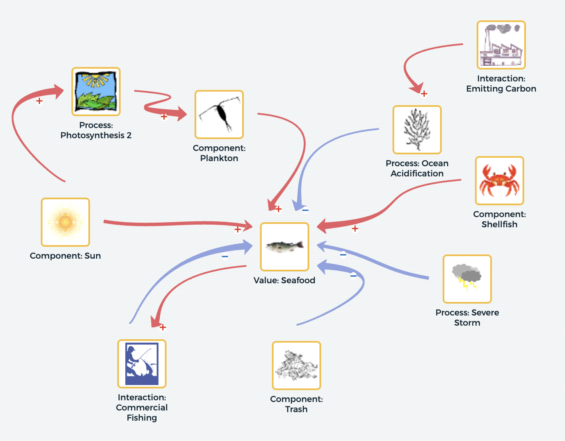

- Save your model when you’re done. Connect to Google Drive to save your model in a shareable location.
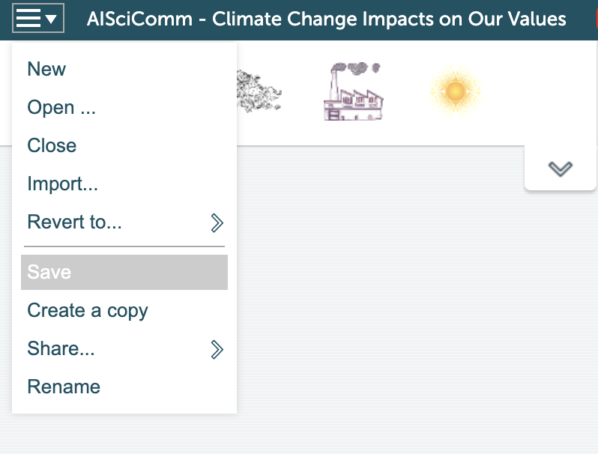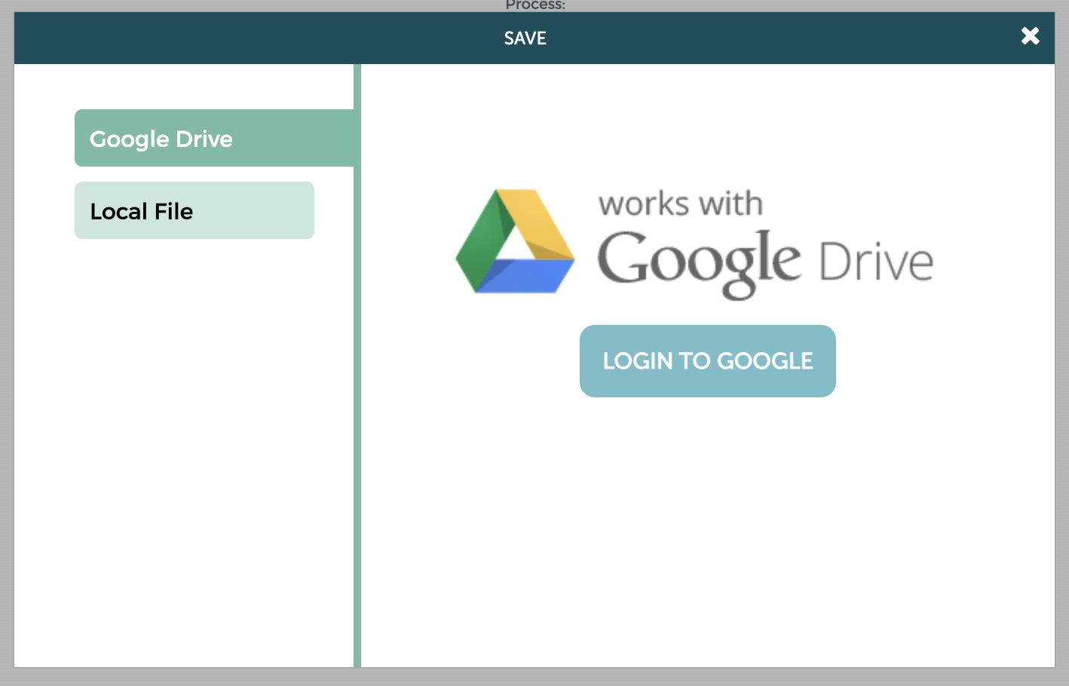

- Now that your team has a complete model, take a moment to simulate change to see how changes in a portion of your model impact your chosen value.

Click on the Simulate icon in the upper right-hand corner of SageModeler to simulate change on a different factor within your model.
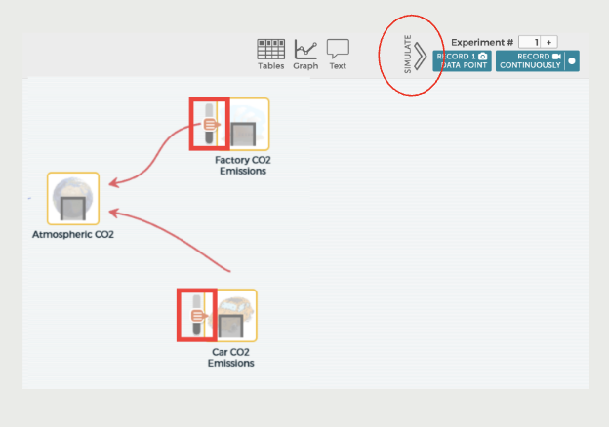
As you test your simulations, think about the following:
How does a change in a component, process, or interaction within your model affect your team’s chosen value?
- Now that your team has completed their model, take a screenshot and save your chatbot conversation in your Google Drive. Save this snapshot as you will need it for Module 4.4.

  - Devices will differ in ways to take a snapshot.
    - If on a Windows computer
      - Press Window + Shift + S at the same time
    - If on a Mac computer
      - Press Command (⌘) + Shift + 4 at the same time
    - If on a Chromebook
      - Press Ctrl + Shift + Show Windows at the same time

